# ABSTRACT

# INTRODUCTION

## PURPOSE

Our project Truth, is a news verification system. It focuses on the integrity of the voting of news articles with Blockchain technology. Verified news articles are added to a database and then displayed under verified articles, while false articles are discarded. A user builds credibility by verifying articles.

## SCOPE

Truth consist of a web service, a mobile application and a website working in unison. The mobile application and website communicates with the web service to access data on the database and the blockchain. The mobile application only displays articles that have been verified. The website registers new users, displays articles and gives the users the opportunity to verify the article by giving it a rating out of four. The administrators are the only users who can add new articles. All of the components are hosted on an EC2 instance. Our project is designed for an audience with little technical knowledge.

# BACKGROUND

“We define “fake news” to be news articles that are intentionally and verifiably false, and could mislead readers.” (Allcott and Gentzkow, 2017:4)

# SOFTWARE SPECIFICATION AND IMPLEMENTATION

## MOBILE APPLICATION

Our mobile application is written in Java through Android Studio. The application does not allow registration or login these features are only available on the website. The application does however display verified articles that are summarized for quick reading. To view the full article the user will need to visit the website. The app receives its articles from the database via the webservice.

## 4.2 WEBSITE

The website is written in HTML, CSS and makes use of JavaScript to communicate with the web service. The website has three sections: the logged in users’ section, where users verify articles, the guest section, where users can only view content and the admin section, where administrators can upload new articles. A logged in user can read and then validate the articles by placing a vote with values ranging from 0(Absolutely False) to 4(Absolutely True) on the desired article. The admin is the only user with the ability to add new articles. The articles are added to the database in the following format: Author, Title, Description and Article Content. The votes associated with the article, are added to the blockchain for verification.

## WEBSERVICE

The webservice is written in PHP and makes use of JSON output for certain values obtained from the (MySQL) database. The webservice handles all communication (requests and posts), from:

* The website to the database,
* The website to the blockchain and
* The mobile application to the database.

## CLOUD

Our project is on an Amazon Webservice (AWS) EC2 instance. The EC2 hosts an Ubuntu server. All of our files are added to the EC2’s localhost directory (/var/www/html/) to load the files from a remote computer via a web browser. Our main blockchain chain is also hosted on the EC2. The instance is loaded with a LAMP stack and multichain software. There are special security groups formed for this instance as well as Elastic IP’s.

## BLOCKCHAIN

A blockchain is a fully decentralized distributed public ledger that keeps track of information, such as transactions, and reconciles the information on every node connected to its network to ensure that it remains transparent and tamper proof. It makes use of cryptography to verify and secure the contents of its network.

We used the blockhain to store and validate ratings or votes given by the user on the validity of an article. This allows us to keep any user who aim to manipulate the rating of an article from doing so.

We have a couple of options to create a blockchain. The first being building one from the ground up and then tailor it to our needs, this would be very time consuming. Another option is to use an existing blockchain like Euthereum to store our data on. This would mean we would have to learn the programing language ‘Solidity’ as well as invest capital into Ethereums own cryptocurrency which is the fuel that executes code and run transactions, the more transactions we have the more expensive this would become. Our final option is to use a platform that allows us to create our own blockchain without the need of building it first such an example is Multichain, its free, light and fast and has an array of features to use in the creation, maintenance and operation of your blockchain simply called from a command line.

To create our blockhain we used Multichain. Multichain has an easy to use API that uses a JSON-RPC client to issue commands to the chain. These commands include storing and retrieving data from the blockchain.

# TECHNICAL DETAILS

## TECHNOLOGIES USED

We have used AWS’s EC2, PHP, HTML, Javascript, Java, CSS and Multichain, MySQL (mysqli), Putty, WinSCP. The group had prior experience of HTML and Java but had to learn the rest of the languages.

## PROBLEMS FACED

The multichain software has little online support and tutorials, leaving us with many problems and questions that we had to answer ourselves. This took a lot of our time. Another time consuming task was the fact that we had to learn a lot of new programming languages to create our project. We also struggled with the connection of the chains through the AWS instance that we have created. Another problem was the creation of the web service, it was difficult and all the online tutorials was rather complicated to understand. The tutorials we found for the mobile app, were all outdated. Sometimes the group experienced problems with communication, and struggled to reach each other for a progress report.

# LESSONS LEARNED

## IMPORTANCE OF EFFECTIVE TIME MANAGEMENT

During the project, we constantly struggled with time management. The time assigned to each task was not enough, so the phases overlapped each other.

## TEAM WORK

When the whole team is not working effectively, the phases are not met in time. The project is a project with a very steep learning curve, making it impossible for only one person. The work has to be divided in manageable pieces for each member. The work breakdown structure has changed through the project and each member adjusted quickly with the new sections assigned to them. The team spirit was positive for most of the project, creating a peaceful, respectful environment for all.

## FAILING FAST

During the project we continuously struggled to fail fast, in other words we kept on struggling with the same problems. This will have to improve to be able to complete future projects more successfully.

# BUSINESS CASE

## EXECUTIVE SUMMARY

**Subject**

We live in a day and age of almost unlimited access to information thanks to the internet. The internet has enabled us to distribute content and communicate across continents in an instant. We all enjoy the ease of access to information, whether it be consuming or creating information for others to consume and discuss, but we never stop to think about the validity of the information we consume. This needs to change, we need to validate and add credibility to news sources in an attempt to stop the distribution of misinformation.

**Scope**

Our scope is small and simple. Create an environment where your readers have the ability to vote on the credibility of your articles that you publish. If an article fails validation it is removed from the “truth” feed as we call it. Only valid articles remain in this feed. The community can therefore be assured that the content in this feed is accurate and validated by the same people that form part of the readers online community.

**Method of analysis**

There are lots of people in the world that are motivated to write fake news articles for a multitude of reasons. They either profit from the act whether it be via advertisement or they get paid for the amount of articles they write regardless of the content. Others are motivated to mislead the public to further their own agenda.

Our business is to create an environment where fake news / hoax writers can be exposed, not to enforce justice on these people but to allow the public access to accurate information.

## OBJECTIVES OVERVIEW

Our first and most important objective is to help create an online environment where news readers can easily establish the credibility of what they are reading. This has become crucial in today’s online environment where fake news has risen as a hot topic as far as social issues regarding the internet is concerned. This is largely because of how social media has changed the way readers gather news these days. Alarmingly, Allcott and Gentzkow (2017:2) noted that of news readers in the United States, 62 percent used social media to get their news, Facebook users were the main culprits for the sharing of fake news stories and a large number of readers reported that they believed fake news stories.

We believe that increasingly, the most reliable news sources will become the most successful. In a business sense, our objectives thus include the desire for news outlets to accept that the verification of their articles will have an effect on the number of readers they have. With the use of misleading titles, more commonly knowns a “clickbait” also on the rise, we aim to reduce the number of clicks any articles that use fake content or misleading titles, to the point where publishing such articles would no longer be worth the time or effort.

In the same way blockchain technology has recently been used to add transparency to the diamond trade, where the trade of blood diamonds polluted the market, we would like to help clean up the news industry in such a way where readers would much rather opt to use outlets that contain this type of verification system on their articles, than outlets that do not. Outlets that have nothing to hide should have no problem in having their articles verified in a fair manner. The idea is then that trustworthy sources should thrive while fake news should die out, or at least have a much less significant impact on today’s society.

The idea, therefore, is that any news outlet should be able to add a similar transparent verification system to their own sites, to earn the trust of their readers and hopefully give themselves the upper hand over rival sites that refuse to use this type of system. Out of a business sense the idea is then that our company should be able to integrate our system with any existing news site and that they would be willing to hire us to do this to give themselves a competitive edge.

## MARKET ANALYSIS

Our target market will be adults aged 20+ who want to read real verified news without wondering if the news is real or fake news. There are approximately 32 259 605 people between the age 15 and 64 in South Africa of which approximately 19 355 763 has access to internet. This will be our target market. With an optimistic forecasting we aim to draw in 80% of the target market which will bring our client base to 15 484 610, with pessimistic forecasting we will gain 20% of the target market which will populate our client base with 3 871 152 clients, our goal is to gain 60% of the target market. We are not targeting a specific income group but rather all income groups with access to the internet in order to provide real news to all people. We will start by targeting South African citizens and in the future expand to a worldwide market, targeting all adults across the globe providing real and verified news to all. Because of our verification system that will verify all news before it is published, we will meet our markets need for real news. The potential market for real news is large as most people want to know that the news they are reading is not fake, they want a reliable source.

There are a lot of competitors in the news industry like news24, BBC news, CCN etc, that provide the latest news but very few of them have methods in place for phasing out fake news and are not capable pf guaranteeing real, reliable news. Since this is a new service we are working on there will be more competitors in the future, but by building a strong support and client base we can overcome this obstacles and keep our market. Pitfalls for entering this market include gaining a client base from our market as well as gaining clients from our competitors so that the service can start. There is a large window of opportunity in this market as there is a demand for the elimination of fake news, it is a time sensitive market because it is an emerging market that we need to take advantage of. There are some regulation that we need to consider for our market, because we will be working with sensitive and private information. Governmental regulation on the sharing of sensitive information and the laws on publishing private information off individuals will be taken in to consideration when publishing news.

## ASSESMENT OF BENEFITS

This project could increase the reputation of any news providing business, because people will know that the news provided, are valid. The journalists still writes the articles and the community will verify it. A high reputation will lead to more online views and higher profits. It will also set the standard very high for every other news reporting businesses, because the technology used in this project is an absolute must-have in the world where false news are increasing daily. The following section will discuss the possible options and give a recommended option.

## OPTION ANALYSIS WITH THE RECOMMENDED OPTION

There are multiple options when it comes to news reporting. In this section we will look at two options and suggest the best option, according to us.

Option one: The news are stored in a database and displayed in a website without the use of a blockchain. The disadvantage is that the users have no way to verify the news.

The second option entails using Blockchain: News could be verified through the use of the community votes and then the validated articles could be printed or posted online. This blockchain technology is still fairly new and not many businesses have this technology yet, giving you the opportunity to stand out. This is a very secure way to do the verification. The users would require little additional training, if any at all.

In our opinion, the best option is to choose option two, even if option one do not have many disadvantages. The security is better.

## KEY DEPENDENCIES AND ASSUMPTIONS

## RISK AND SENSITIVITY ANALYSIS

Possible risks for the service we want to provide include but are not limited to law suits for posting private information of an individual, lawsuits for posting government sensitive information, law suits for posting an article of a journalist that has rights on the article. All off these risk are high risks as it can lead to the discontinuation of our service. These risks need to be avoided by researching and analysing the articles on our news service ensuring that we follow all legal obligation before publishing it. These risks take a high priority and can have a large impact on our service.

|  |  |  |  |  |  |
| --- | --- | --- | --- | --- | --- |
| Risk Register | | | | | |
| ID | Description | Probability | Impact | Risk Score | Priority |
| 1 | Plagiarism | 6 | 7 | 42 | 1 |
| 2 | Posting government information | 2 | 9 | 18 | 3 |
| 3 | Posting private information | 4 | 7 | 27 | 2 |

The probability score works on a scale from 1-10, 1 meaning it is unlikely to happen, 10 meaning it is very likely to happen. The impact score works on a scale from 1-10, 1 meaning it will have no real impact on or service, 10 meaning it will have a large impact on or service. Avoiding plagiarism is our main priority to avoid according to our risk analysis.

## RESOURCE REQUIREMENTS AND COSTS

The interesting aspect of using blockchain technology out of a resource and cost perspective is that apart from your regular resources used for hosting, the blockchain part of your system works completely differently. Out of a software point of view there are not any costs involved in using Multichain for development. Out of a hardware point of view it becomes more complicated, as hosting a blockchain requires several devices linked in a fully distributed manner. On a small scale this is not much of an issue, but scalability makes things all the more complicated. Out of a business perspective it would be wisest to find some way of rewarding users who allow their physical devices to form part of your blockchain. Of course this was an easy problem to solve for cryptocurrencies such as bitcoin who would reward users who mined with small fractions of their currency. We are however not working with a currency, so some form of incentive must be created. Of course we aim to establish a community of internet users who would like their daily browsing not to be polluted by fake news. Whether or not this would be enough reason for readers to be willing to become part of the blockchain is unpredictable, but considering your average internet user, it would unlikely be enough incentive. Other rewards could include handling users who are actively part as the blockchain as users with a sort of premium membership to your site, giving them extra privileges.

Using Amazon Web Services has become the easiest way to host your system on the internet today. It is incredibly flexible, especially in terms of scalability, as we can use lightweight, cheap options for development and testing, but you can scale up what you pay for at any time according to your need, without having to work with any hardware yourself. As most blockchains are only a few gigabytes large, but known as quite a slow way to handle data, one could expect that using an AWS EC2 option focused more on computing would be the smart move. According to Amazon “C4 instances are the latest generation of Compute-optimized instances, featuring the highest performing processors and the lowest price/compute performance in EC2.” These instances range from c4.large to c4.8xlarge, which range in memory from 3.75 gigabytes to 60 gigabytes. The price range to have these instances deployed 24/7 ranges from 101.75$ per month to 1675.63$ per month, although it is unlikely that such an expensive option would be necessary. It would be unlikely to need an instance larger than a c4.xlarge, which prices at 203.50$ per month.

# RECOMMENDATION FOR FURTHER RESEARCH

The Truth project has tremendous potential that can still be developed and refined. Our project covered only a small amount of possible opportunities when it comes to Blockchain. Truth only validates the votes associated with the article validation. Further studies could possibly be based on adding articles to the blockchain, along with the votes and login information of the users. Due to the limited resources and no prior experience with blockchain, the project had a small scope, which could be broaden with additional knowledge and training on Blockchain.

Features that could have been developed with extra resources:

* Validation for voting. Making sure a user doesn’t sabotage the verification process, an example would be like voting false on every article.
* Users can have a reputation. Each user has a reputation which comes with a certain weight. Other users can vote for that user’s reputation, giving them a heavier weight in the voting system.
* Groups can be formed to improve security and certainty of the validation of each article. Groups would obviously carry a larger weight in the voting system.
* Blockchain can be used to secure the system and make it virtually impenetrable. Because it is a distributed database it can’t be hacked from, let’s say 50 locations.
* The mobile app could be expanded to facility login, registration, admin features and article voting.

# CONCLUSION

In conclusion we aim to use modern technologies such as the blockchain to enable users who use our website to read news articles to verify the articles content so that other users can be certain the content they read is valid and accurate.

We aim to show other news agencies the importance of validating your content through a technology like the blockchain so that their readers can have the peace of mind of receiving factual accurate and valid information.

We also want to expose those who create fake news and hoaxes and protect those who are affected by misinformation by providing them a platform to collectively contribute and validate the content they read and share with others.

We feel that a project like this can be beneficial with further exploration experimentation and research.

# BIBLIOGRAPHY

Africa, S. (2017). *Community Survey 2016 | Statistics South Africa*. [online] Statssa.gov.za. Available at: http://www.statssa.gov.za/?page_id=6283 [Accessed 23 Oct. 2017].

Allcott, H. and Gentzkow, M., 2017. *Social media and fake news in the 2016 election* (No. w23089). National Bureau of Economic Research.

Bplans Blog. (2017). *How to Write a Market Analysis - Bplans Blog*. [online] Available at: http://articles.bplans.com/how-to-write-a-market-analysis/ [Accessed 23 Oct. 2017].

https://aws.amazon.com/ec2/instance-types/#instance-details

http://calculator.s3.amazonaws.com/index.html#s=EMR

Shezi, L. (2017). Number of South Africans with access to internet grows to 60% - htxt.africa. [online] htxt.africa. Available at: http://www.htxt.co.za/2017/05/31/number-of-south-africans-with-access-to-internet-grows-to-60/ [Accessed 23 Oct. 2017].

# APPENDICES

## APPENDIX A: TEAM INFORMATION AND WORK BREAKDOWN STRUCTURE

* the work-breakdown structure of the entire project through every phase.
* a section dedicated to how your group used *git* and *slack* to facilitate group development. How did it work for you? What were the benefits/challenges? Should it be a requirement next year? What tools/technologies would you like to see used in this module. Discuss and give feedback.
* a section dedicated to self-review:
  + what did your group learn in this development project (technical and non-technical)?
  + what development methodology did you use (if any), how effective was it. Would you choose a different approach if you could re-do the project?
  + how did the experience affect the way you'll approach development projects in future?
* a section evaluating your own product:
  + What are its best characteristics?
  + Given more time, what would you improve?
  + How effective is it in solving the problem you identified initially?

## APPENDIX B: USER MANUAL



**Home Screen ->** Welcomes the user to the Truth! Website.

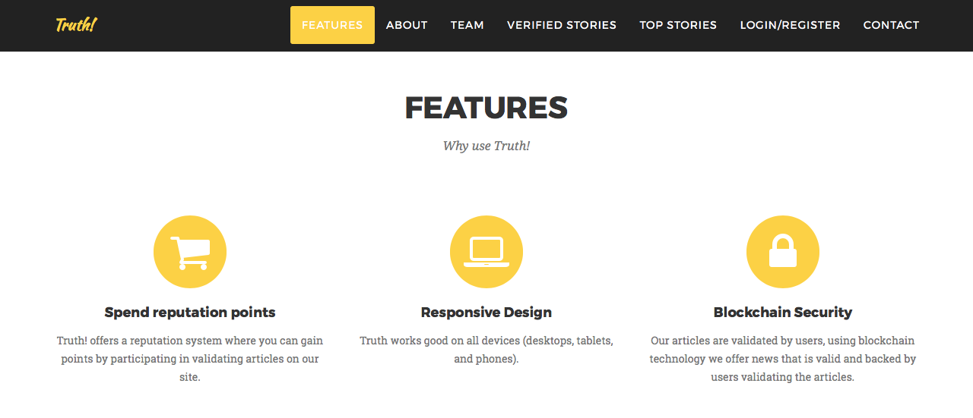

**Features Page ->** Display some of Truth! Interesting features.

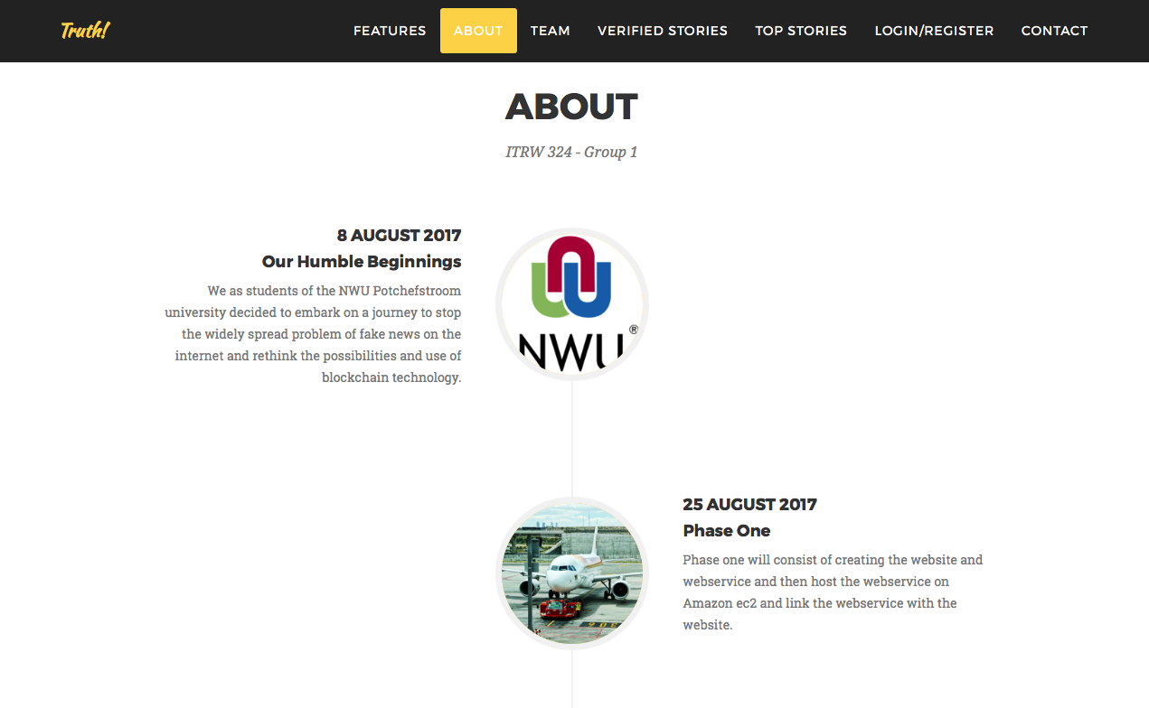

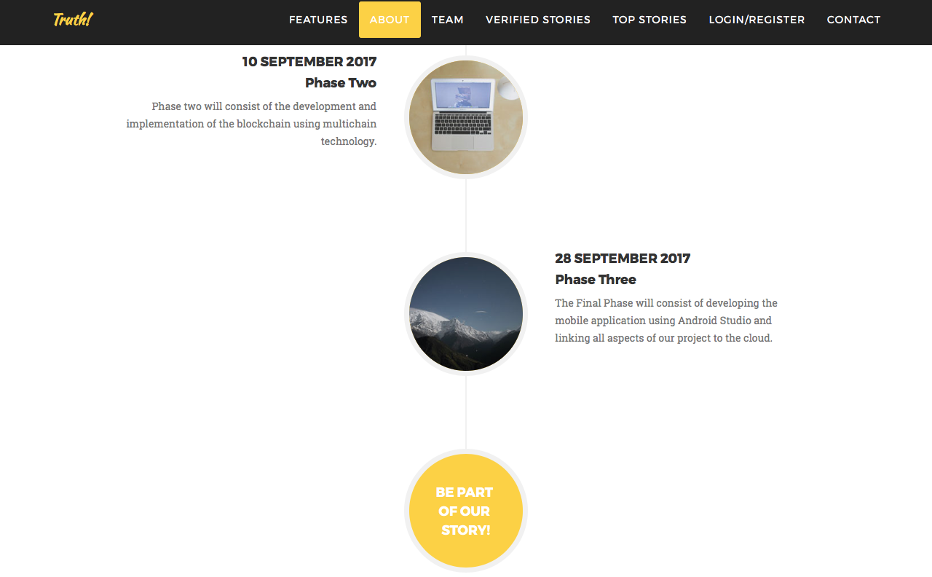

**About Page->** Gives a bit of background information on our group and what we aim to achieve in each of our phases.





**Team Page ->** Introduce our team of developers and share links to their Facebook and LinkedIn profiles.

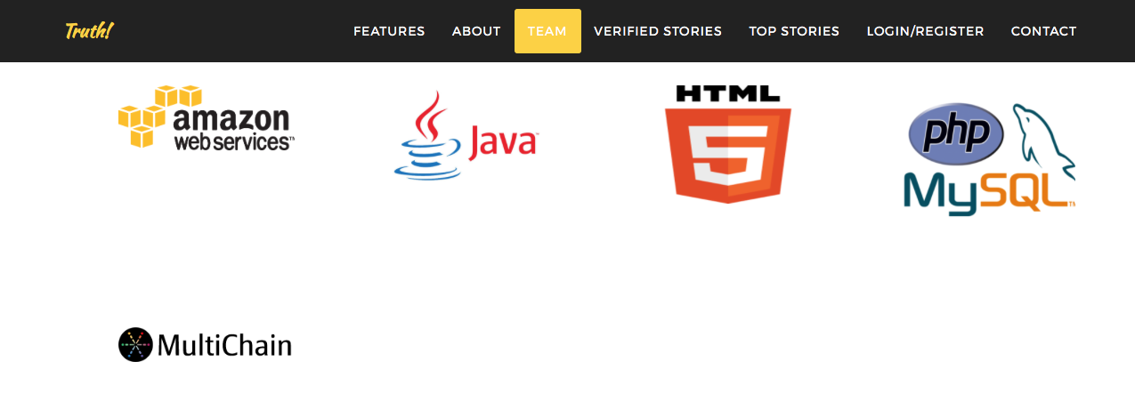

**Team Page ->** Showcase some of the technologies used creating the Truth! Platform.

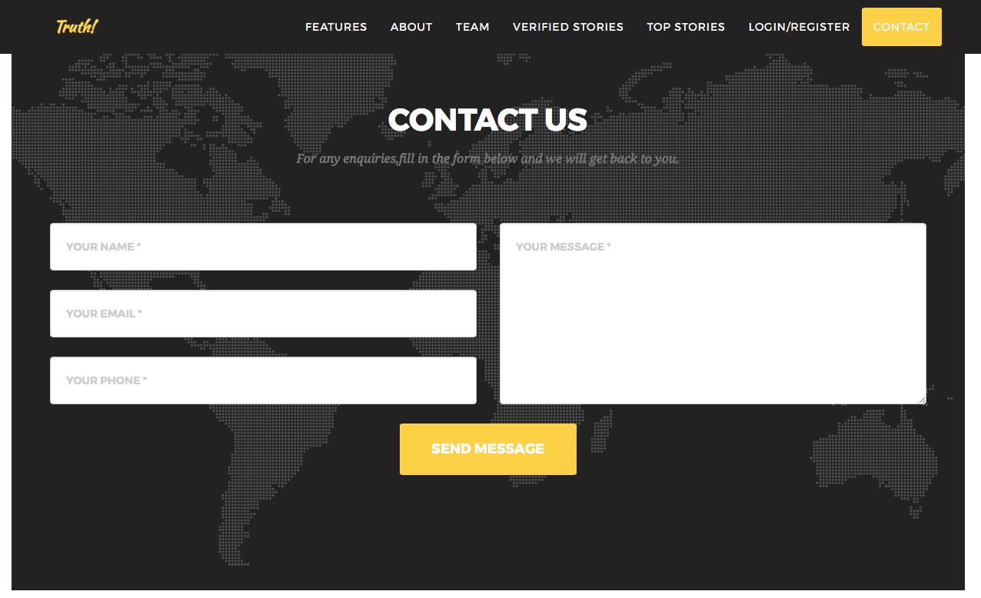

**Contact Page ->** Let’s users get in touch with the Truth! Team.



**Top Stories Page ->** The top stories page displays all new unverified articles that awaits ratings from user. This page is only a summary of the articles once selected the user will be redirected to the corresponding article page where the user can then rate the article.



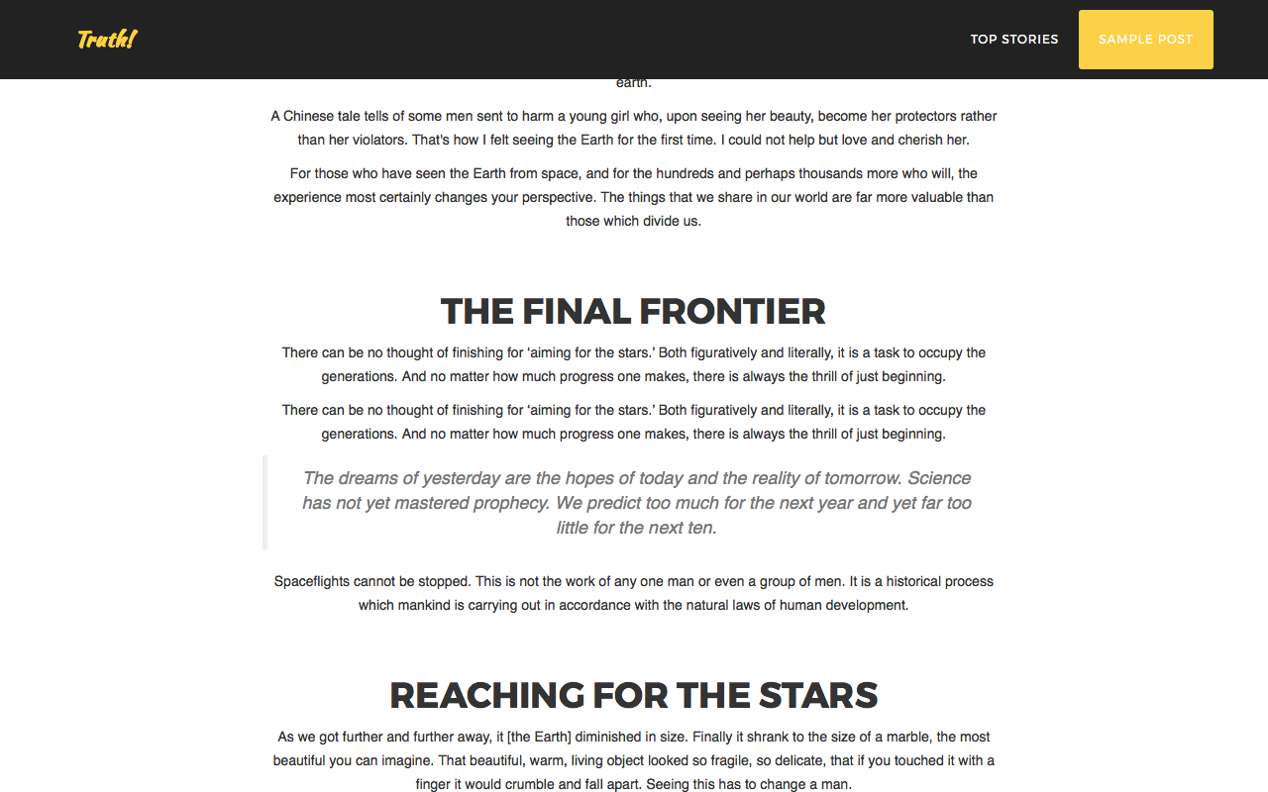

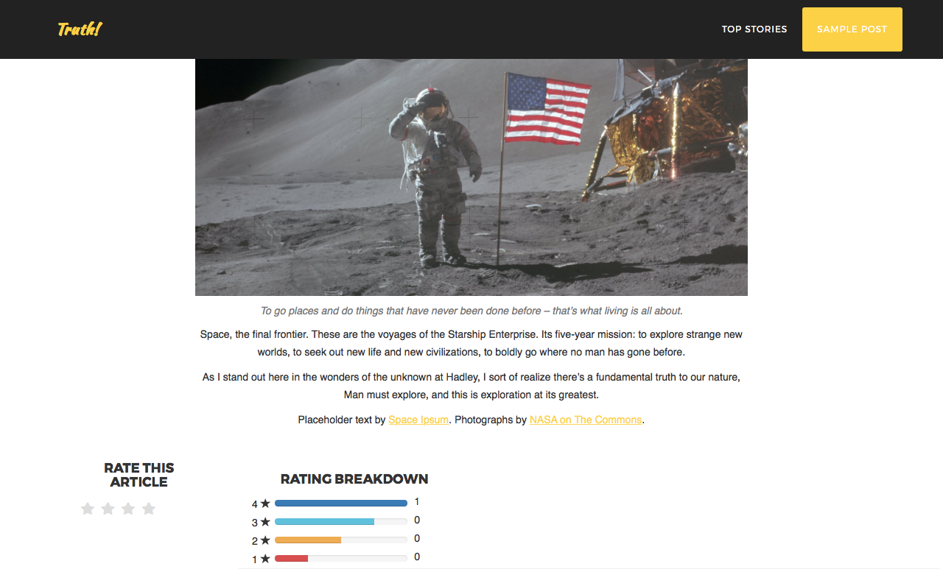

**Article Page ->** The article page display the corresponding article that was selected in the top stories page. Here the user can rate each article once and can also see a breakdown of the ratings the article already have.



**Verified Stories Page ->** All articles that was successfully verified as news that not fake will appear on this page and the user will no longer have the function to rate the article.

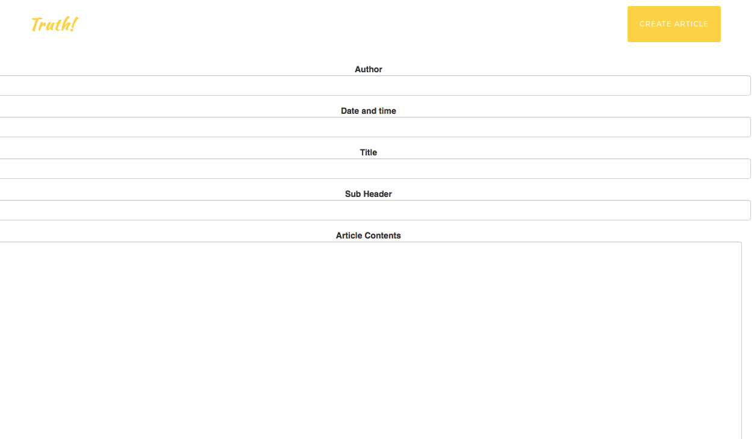  
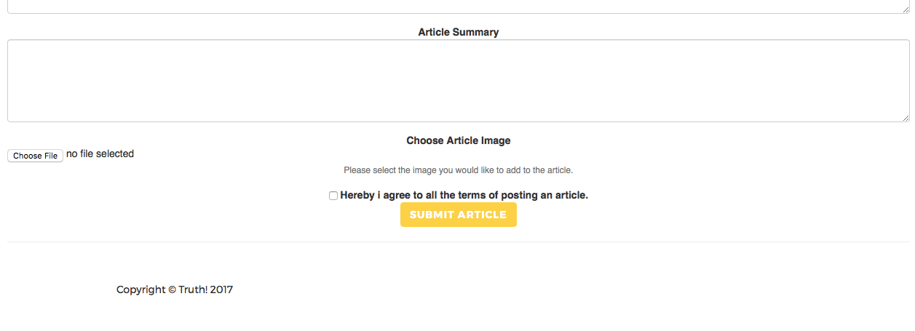

Create Article Page -> Enables admin users to post articles easy and efficiently using our article templates.

Registration

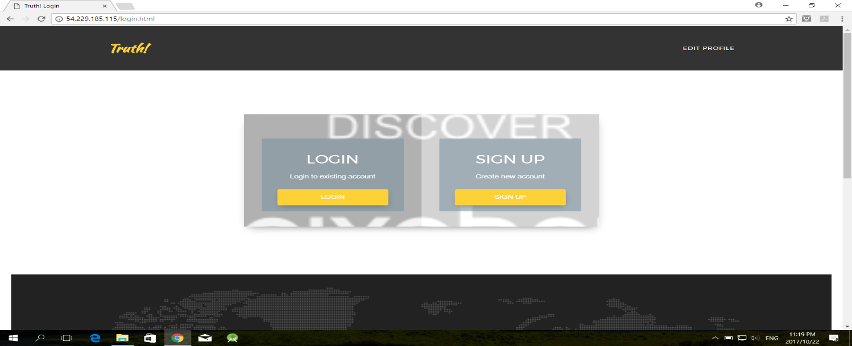When the user reaches the login page he will see the following:

From here the user can register by filling in the required fields. The user must fill in each field and the passwords must much otherwise an error will occur:

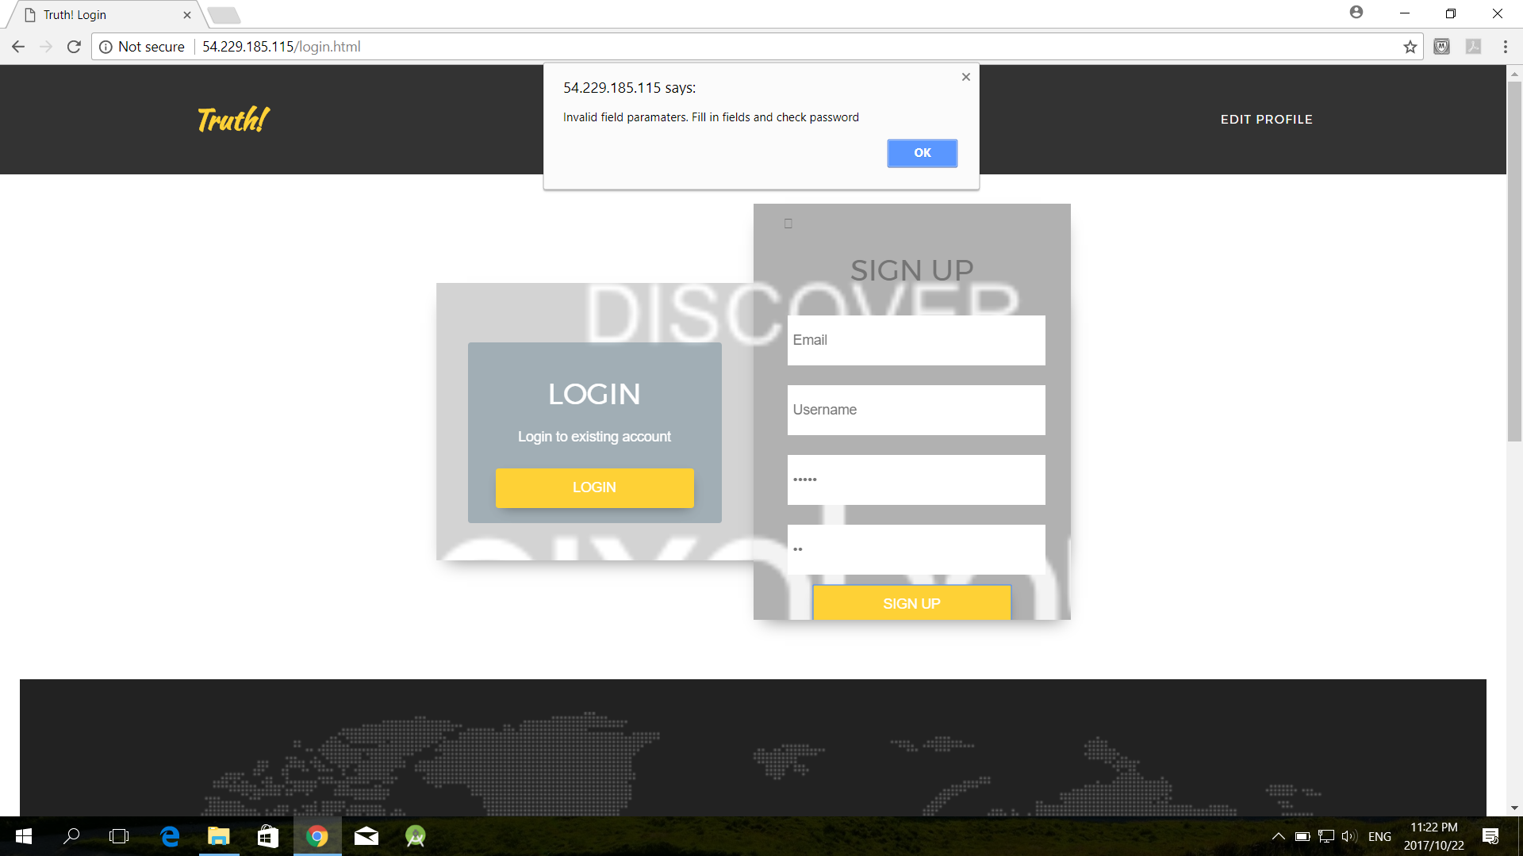

Once a user is successfully created the user is redirected to the home page:

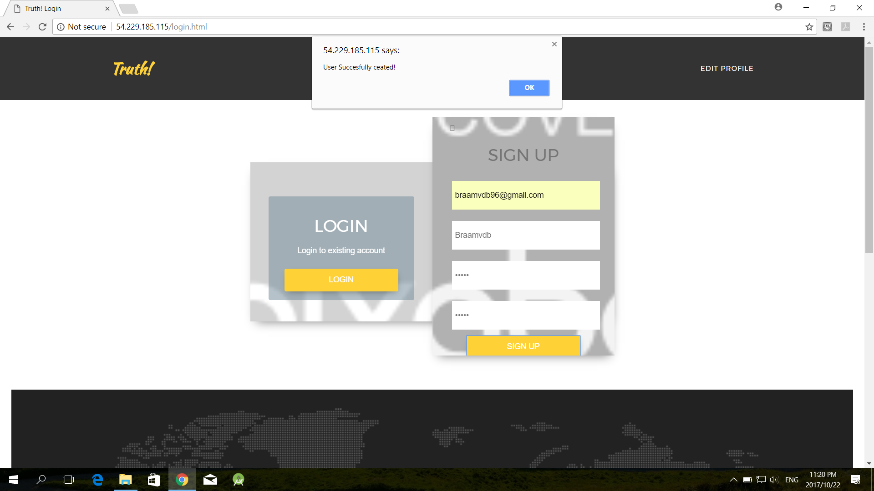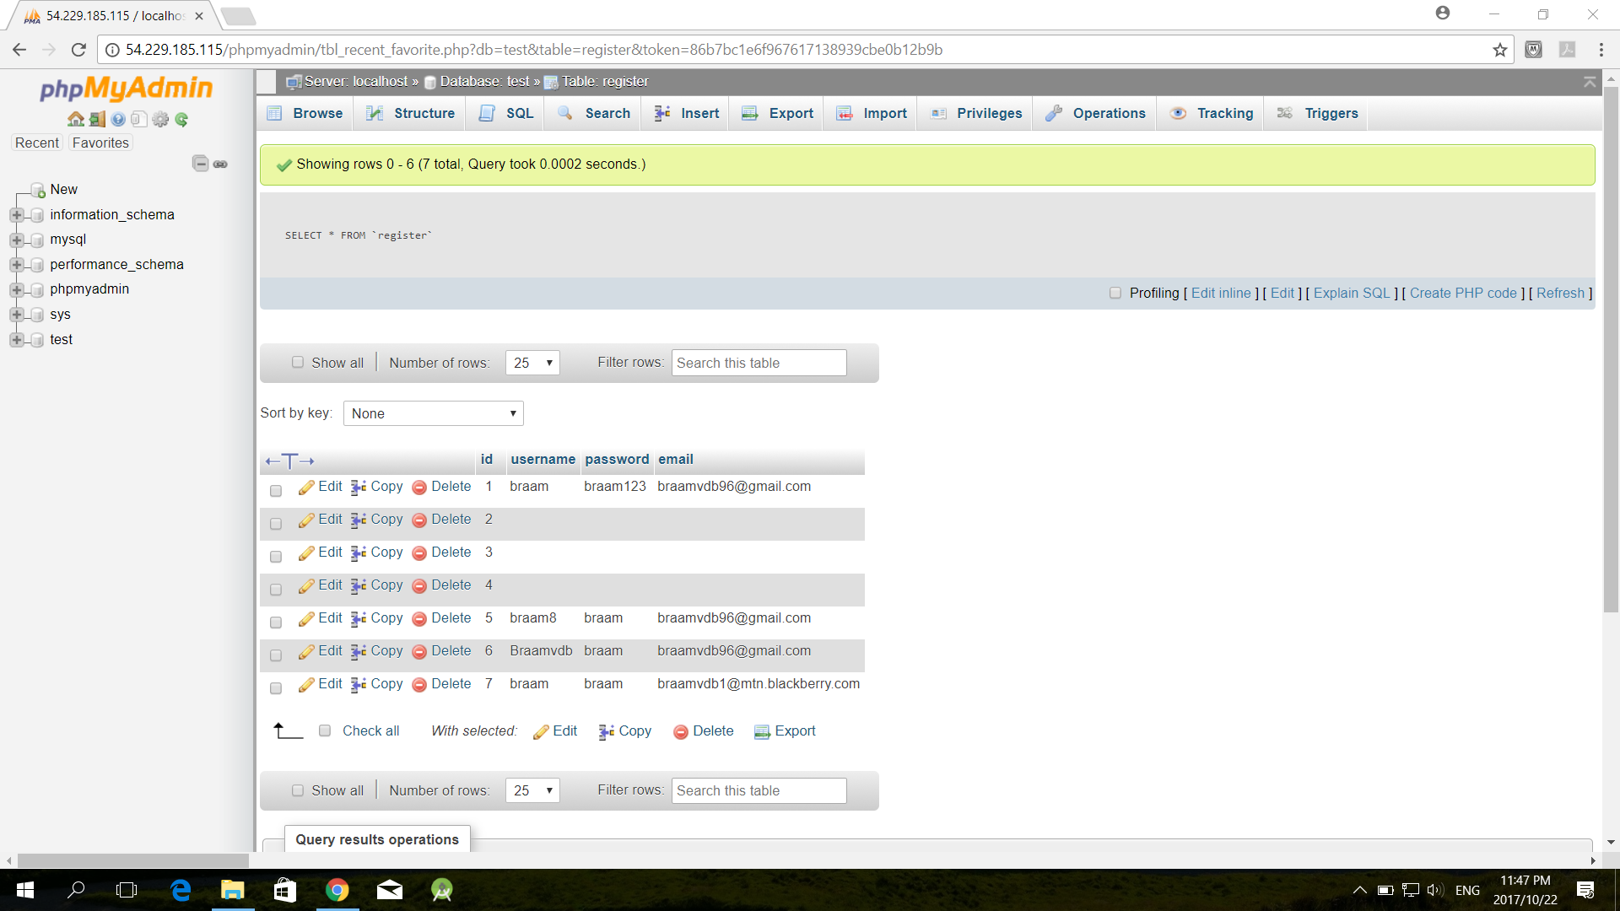



Login

When a user exits, and has already been registered, and wants to log in he can do so using the username and password created in register:

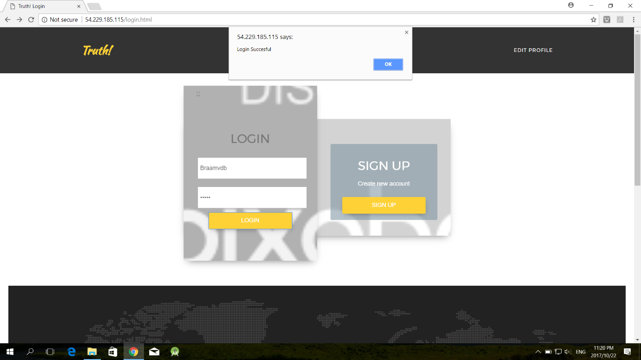

When a user is successfully logged in he is redirected to the home page. When the log in fails he is redirected to the login page to try and log in again:

When the Admin user logs in with the given credentials he is redirected to the Create Article page for admin users.

